2013
Fordham University – Brazil

Sao Paulo, Belo Horizonte, Rio de Janeiro
March 09 – March 17, 2013

Day 1 | New York – Sao Paulo
Mar 09  Sat | Arrive New York-JFK Airport minimum 3 hours prior to departure / Met by DP Rep for Check In  Depart on Tam Flight 8081 at 6:40pm

Day 2
Mar 10 | Arrive Sao Paulo 6:35am / Clear Customs & Immigration / Welcome to Brazil!
Sun | Met by Guide outside of baggage claim for transfer to hotel
Afternoon Half Day City Tour (Pinacoteca & Soccer Museum)
Overnight at Quality Suites Imperial Hall

Sao Paulo City Tour
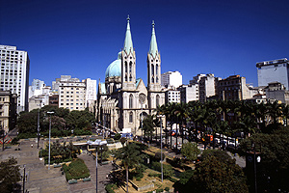
On this tour we will travel to the traditional places of São Paulo. We will begin with the oldest train station in the city, the ESTAÇÃO DA LUZ (Luz Station). It was inaugurated in 1867 and its architectural beauty remains, to this day, one of its most noteworthy features. A stop will be made at the Butantã snake farm, a world known institution where snakes are kept for poison extraction, which later is used as antidote against snake bites and tropical diseases. We will continue towards the TERRAÇO ITÁLIA (ITALY TERRACE) one of the most charming buildings of old downtown. Next we will see the TEATRO MUNICIPAL(Municipal Theatre) where we stop to walk around and get to know different places of the old downtown such as, the VIADUTO DO CHÁ(Chá Viaduct) , BANESPA BUILDING, PATIO DO COLEGIO(Schoolyard) AND CATEDRAL DA SÉ( Sé Cathedral) with its splendid stained glass. Afterwards, we will go inside the cathedral, take pictures and appreciate the busy downtown. Then we will go to the neighborhood of LIBERDADE. This neighborhood has the highest concentration of Japanese immigrants living outside of Japan and adorned with typical decorations. We will go into the financial center of Sao Paulo and pass by Paulista Avenue, the most important street, full of modern buildings such as the MASP (Art Museum of Sao Paulo). Finally, we end our city tour in the one million square meters IBIRAPUERA PARK to visit the museum designed by Oscar Niemeyer.

Day 3
Mar 11 | Buffet breakfast served at hotel's restaurant
Mon | 8hr Bus at Disposal w/Guide for Bank Meetings
 | Evening at leisure
 | Overnight at Quality Suites Imperial Hall

Day 4 | Sao Paulo – Belo Horizonte
Mar 12 | Buffet breakfast served at hotel's restaurant
Tue | 6hr Bus at Disposal w/Guide for Steel Plant or Santos Pier
Late Afternoon Transfer to Airport
Depart Sao Paulo on Tam Flight 3224 at 6:38pm / Arrive Belo Horizonte 7:55pm
Transfer in Airport to Hotel
 | Overnight at Clarion Lourdes

Day 5 | Belo Horizonte – Rio de Janeiro
Mar 13 | Buffet breakfast served at hotel's restaurant
Wed | 6hr Bus at Disposal w/Guide for mine visit
Evening Transfer out to Airport
Depart Belo Horizonte on Tam Flight 3755 at 6:26pm / Arrive Rio de Janeiro 7:26pm
Transfer in Airport to Hotel
Overnight at Mirador Rio

Day 6
Mar 14  Thur | Buffet breakfast served at hotel’s restaurant  8hr Bus at Disposal w/Guide for Bank & Olympic site visits  Roundtrip Transfers for dinner (3hrs, meal not included)  Overnight at Mirador Rio

Day 7
Mar 15  Fri | Buffet breakfast served at hotel's restaurant  8hr Bus at Disposal w/Guide for Bank Meetings  Secrets of Old Rio Walking Tour  Overnight at Mirador Rio

Secrets of Old Rio Walking Tour
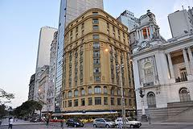
This is a unique walking tour which gives visitors a feeling for the legends and stories woven around the narrow streets and old historical buildings of downtown Rio. The walk includes a visit to many interesting points such as the São Bento Monastery, Candelária Church, Praça XV, the "Travessa do Mercado", Imperial Palace (‘Paço Imperial’), the cultural center located in the beautifully-restored Banco do Brasil, the Casa França-Brasil, Ouvidor Street and Gonçalves Dias Street with the traditional Colombo Coffee Shop. The walk continues on down Uruguaiana Street, Carioca Square, and up to the Metropolitan Cathedral.

Day 8 | Rio de Janeiro – New York
Mar 16  Sat | Buffet breakfast served at hotel's restaurant  Optional: Full Day Corcovado, Sugarloaf & Tijuca Forest  Evening Departure for Airport  Depart Rio on Tam Flight 8078 at 10:15pm

Corcovado by Tram
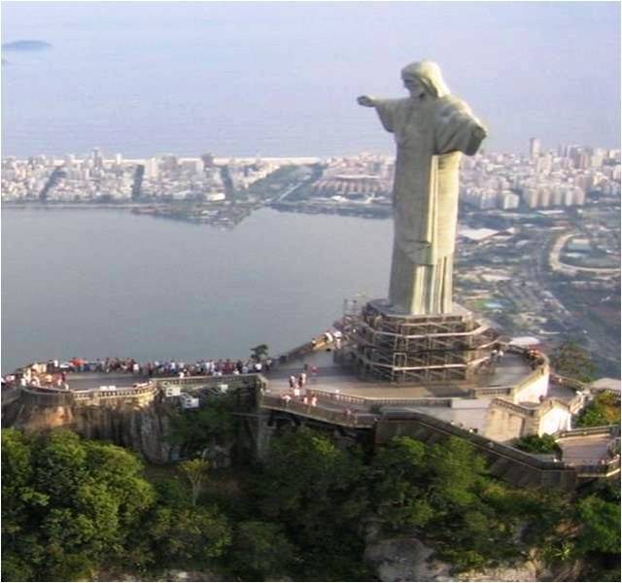
A visit to the Christ Statue recently elected one of the seven modern wonders of the world. The statue sits 2,300 ft. above sea level, atop Corcovado Hill. You will start your way up on a small train that climbs the beautiful mountainside. Upon reaching the top, visitors will admire a panoramic view of Rio de Janeiro and discover why it is known as the “Marvelous City”! The tour also includes a drive along Rio’s famous beaches.

Sugar Loaf by Cable Car
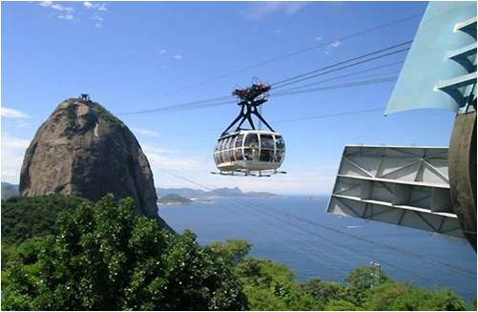
Over a million tourists each year visit the world famous ‘Pão de Açúcar’ (Sugar Loaf Mountain), which has become an iconic symbol of the city of Rio de Janeiro, rising up from a small peninsula at the entrance of Guanabara Bay. The journey to the top is made in glass cable-cars. The first cable-car takes passengers to the top of Urca Hill, which rises 215 meters above sea level and offers spectacular views of the entire bay and its surrounding islands. From Urca Hill, passengers continue in a second cable-car to the top of Sugar Loaf which rises 395 meters above sea level and offers a 360 degree view of the entire city including Botafogo and Copacabana Beaches, Corcovado Mountain and downtown Rio de Janeiro. Before returning you will stop by the Municipal Theater and the Cathedral in the center of the city.

Tijuca Forest Jeep Tour
Jeep tour in the Tijuca Forest shows the contrasts between the big city and the forest.We drive through the forest and stop at the Chinese View (a lookout point), Emperor’s Table, Taunay waterfall and Mayrink Chapel. We will also make a light walk thought a trail in the heart of the forest, giving us a chance to be in contact with nature, with expert guides who will explain everything about the Atlantic Forest.
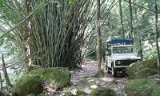

Day 9 | New York
Mar 17  Sat | Arrive New York- JFK at 7:25am. Welcome Home!

Hotel Selection
Sao Paulo – 3*: Quality Suites Imperial Hall
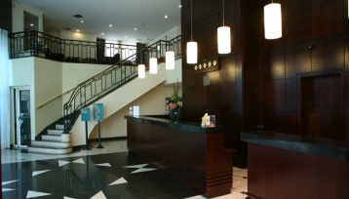 | Quality Suites Imperial Hall is one of the most prestigious of São Paulo. Located in the heart of Jardins on the corner of Rua Oscar Freire, one of the most important shopping streets in the world, it is close to Avenida Paulista and Culture and Convention Center Rebouças.

Bello Horizonte – 3*: Clarion Lourdes
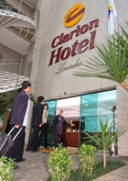 | The Clarion Hotel Lourdes is located in one of the best neighborhoods in Belo Horizonte, just two blocks from the Diamond Shopping Mall and surrounded by prestigious shops and restaurants. The access to the main business and convention centers is fast and easy.

Rio de Janeiro– 3*: Mirador Rio
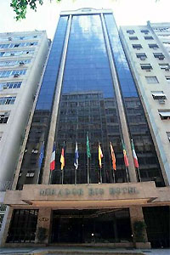 | Only three blocks from the beach, the Mirador Rio is perfect for tourist or business travelers. The hotel has 138 rooms all featuring cable TV, internet access, a telephone, air conditioning, a sound system, a hairdryer, a mini-bar, and a personal safe. Also available for the guests’ enjoyment is a rooftop bar with breathtaking views of Corcovado, and Sugar Load Mountain, a fitness center, a pool, and a sauna. The restaurant offers complete breakfasts and delicious international cuisine for lunch and dinner

Study Tour Cost: $2720. (tentative)
Priority will be given to Seniors majoring or concentrating in Finance.
Minimum GPA: 3.0
Prerequisite: Principles of Financial Management

Deadline: November 29 – $500 Deposit Due.
Sign-up: Ms Susan Brucculeri – 4th Fl. Hughes
Info. Contact: Assistant Dean Michael Polito – mpolito6@fordham.edu

The quote includes:
• Accommodation, transfers, tours, services and meals as per itinerary above;
• International & Domestic airfare as noted itinerary;
• English speaking guides and air-conditioning transportation;
• Porterage at airport and hotel. (1 piece/ pax);
- International air taxes of $102.72 per person, subject to change until ticketed.
• All city taxes.

The quote does not include:
• Drinks during meals – unless mentioned otherwise;
• Personal expenses;

Financial Modeling of Emerging Markets; Brazil Study Tour
FNBU 4471 – R01
Spring 2013 Semester
Instructor: David Talbot, McKinley Capital Management
Class Hours: 5:30pm–7:30pm selected Mondays during semester
Readings: Brazil on the Rise: The Story of a Country Transformed by Larry Rohter
“Value Investing: From Graham to Buffett and Beyond”, by Bruce Greenwald, 2001, Wiley Finance

Description of Course: In the Brazil Study Tour, students will learn how to model and evaluate individual Brazilian equity securities in the context of their relevant global sectors and in the context of Brazil’s economic, political, and social framework.

How should we learn? Emphasis on the WE

- We must first learn about the Brazilian Constitution, Its Government , its Ministries and its Treasury.

- Industry and Investment – Let’s go to the smartest people in the investment community – the best financial analysts – and work out how to make money!

- Where Should I Invest a Dollar to get the Highest Return!

- Each team of 2 students will be asked to select a company that represents the best in its industry.

- They will build a financial model on that company which will evaluate the five-year outlook and include an interactive P&L, Cash Flow and Balance Sheet.

What Will We Achieve?

During the course of the eight two-hour lectures this semester, you will spend one week in Brazil meeting with strategists and analysts:

YOU WILL KNOW AS MUCH ABOUT INVESTING IN BRAZIL AS ANY PROFESSIONAL IN NEW YORK CITY.

You will have made many personal contacts in the Investment Banks in Brazil.

You will learn from some of the top Financial Analysts in the world how to present an Investment case around ten individual companies.

- You will know how to analyze one of the world’s fastest growing economies
- You will have a detailed knowledge of ten of the country’s largest companies
- You will have learnt to build an interactive financial model
- You will understand the basics of government
- You will know the major cultural classifications of the country
- You will know something of the history, culture and traditions of the country
- Indian people will respect you for your understanding of their country
- You will taste the food of Brazil

Organization of the class: Students will work in teams of 2 persons each.

Research Report: Each team will present a comprehensive research report on a specific Brazilian stock. The report will include an analysis of the sector, comparable ratio analysis of competitors, SWOT analysis, detailed financial model and review of relevant research opinions.

